# Send email to [jaspreetsingh.paintal@wu.com](mailto:jaspreetsingh.paintal@wu.com) asking him to obtain preapproval for laptop. Please copy [HR@quantsystemsinc.com](mailto:HR@quantsystemsinc.com) on the request as well as bonita.selke@wu.com.

# Jaspreet will request approval and forward the approval once it is received. You will need to attach this approval to the request ticket following the steps below. Do not go further without prior approval.

**After approval received:**

# Log into Okta

Open your Okta: <https://westernunion.okta.com/> (can be done outside of VDI)

# Open Service Now

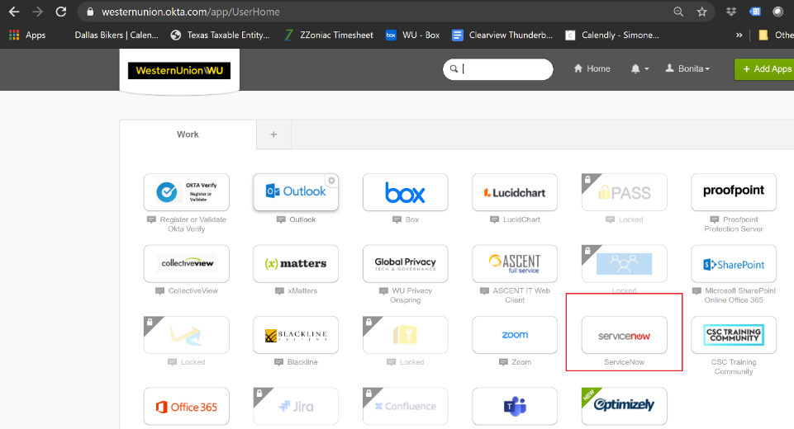

# Click on “IT General Request – Service Requests”

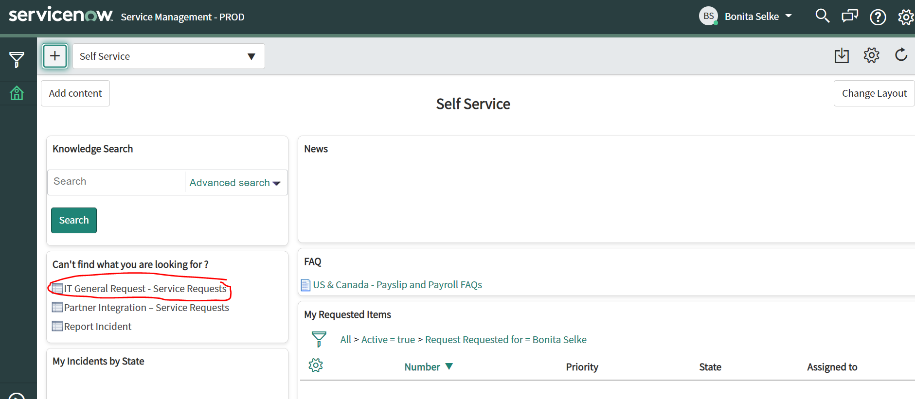

# Enter “pc replacement” in the search box then click on “all categories”

# Click on “PC Replacement” to select and open form.

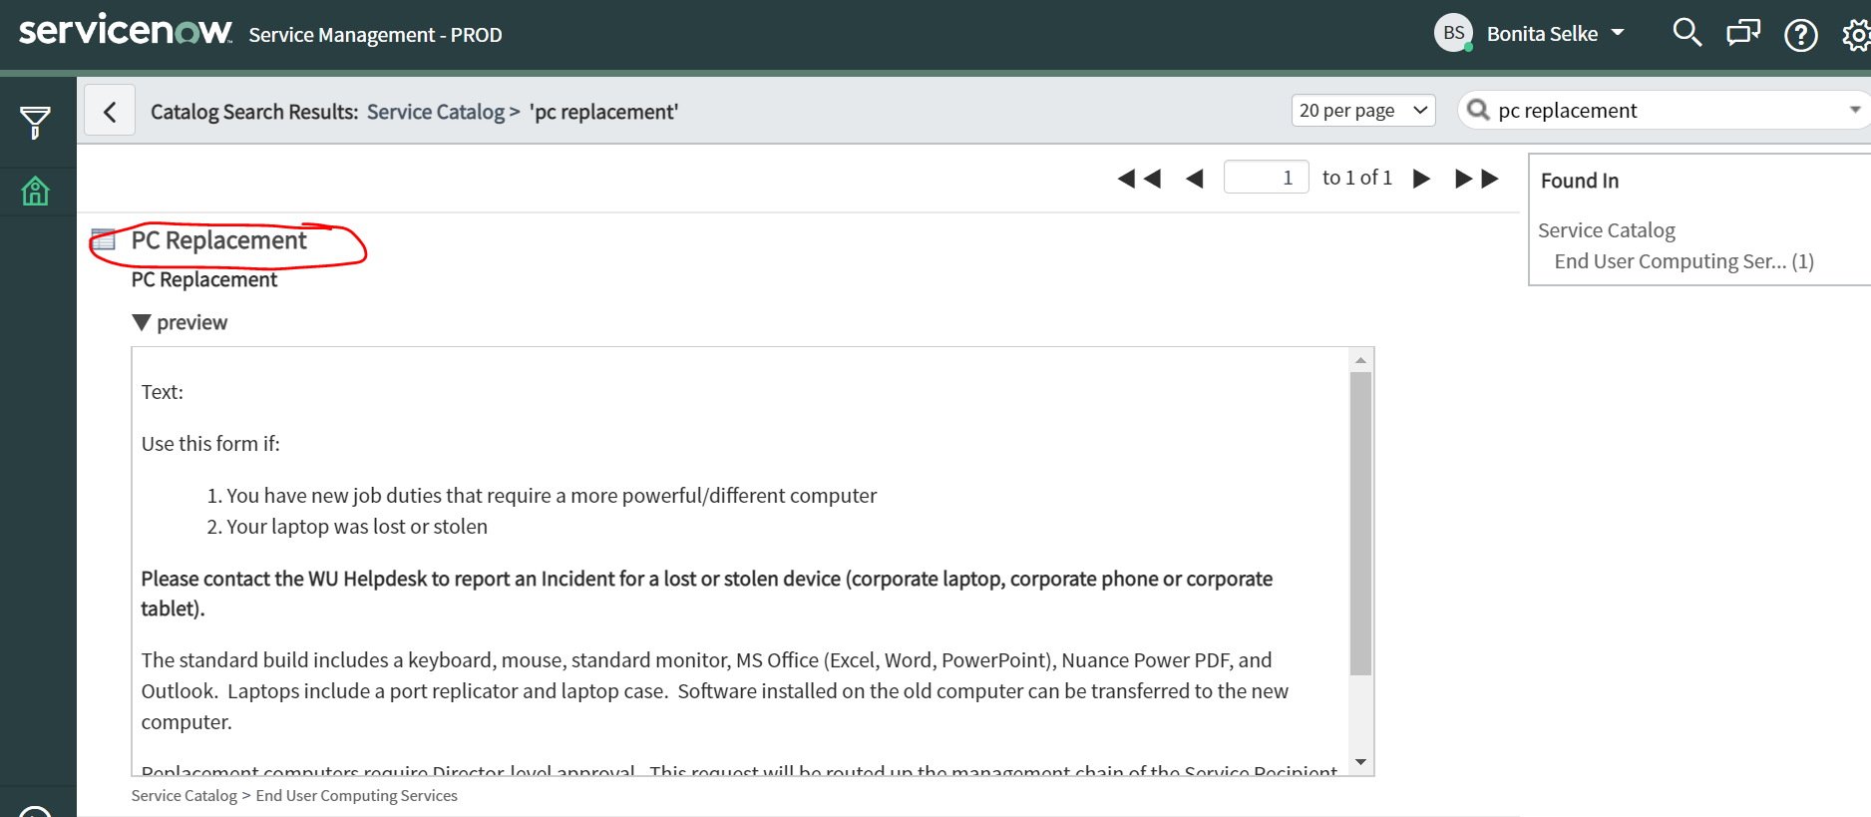

# Enter required fields & click submit. For short description, please enter: “**Quant Systems – Your Name – Request Laptop**”. Example of short description “Quant Systems – Bonita Selke – Request Laptop”. In the Description field, “**Please see attached justification and approval for contractor laptop**.”

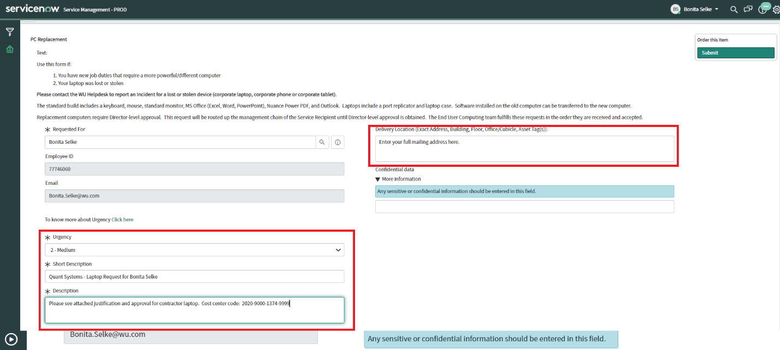

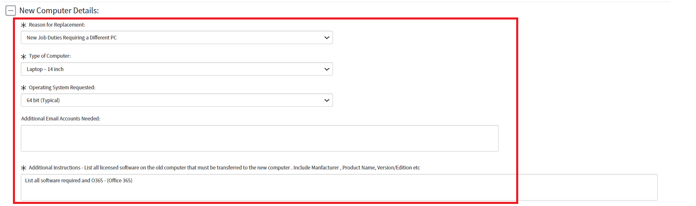

# Scroll back up to top and attach the email approval and click the Submit button.

